**CSCI 360 1. Allocating Your Assignment PDSE**

To program on the mainframe, it is necessary to first create, or allocate, a data set known as a partitioned data set extended (PDSE) where your code will be stored. What follows are the steps necessary to allocate your assignment PDSE that you will use all semester. During the first week of class, your instructor will show you how to back up this important data set so that you have something to go back to if you delete it.

First, download a copy of Tom Brennan's Vista TN3270 at:

<http://www.tombrennansoftware.com/download.html>

For those of you wishing to use Adobe's *Source Code Pro* fonts, download the V2.00 Preliminary Test Version at:

[http://www.tombrennansoftware .com/v200/](http://www.tombrennansoftware.com/v200/)

With either version, you will have to use the current Vista TN3270 registration name and code so that your copy will not expire after the software's trial period. This can be found in Blackboard's Course Documents.

Each time run Vista TN3270, you will be presented the following:

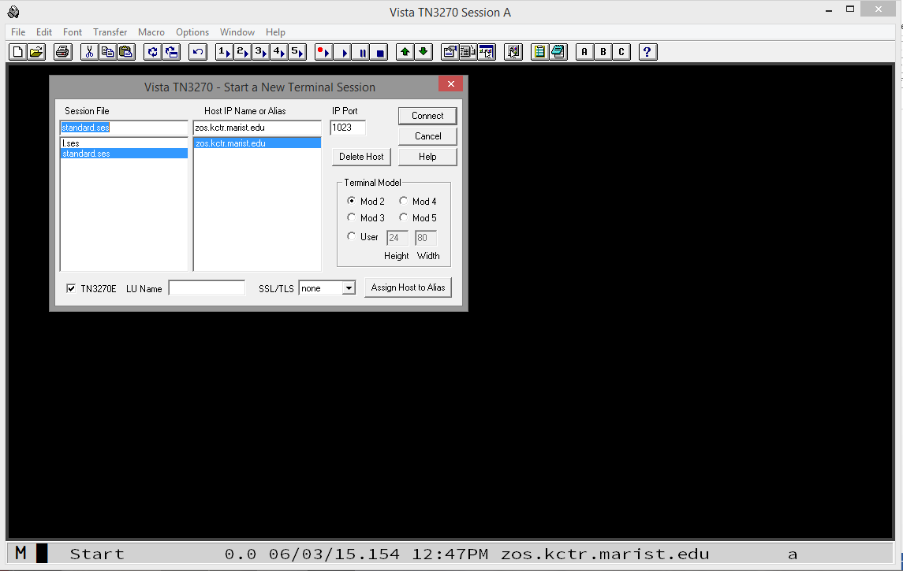

To connect, enter Host IP Name zos.kctr.marist.edu and Port 1023 and click Connect. You will be presented the following:

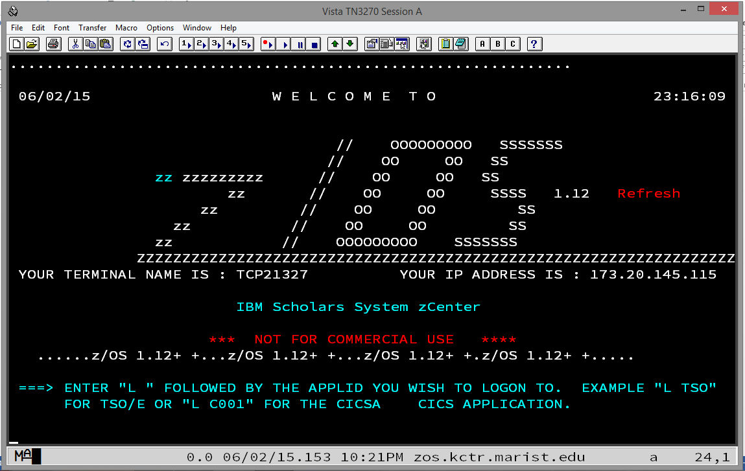

Type the letter L and press Enter. You will be presented the following:

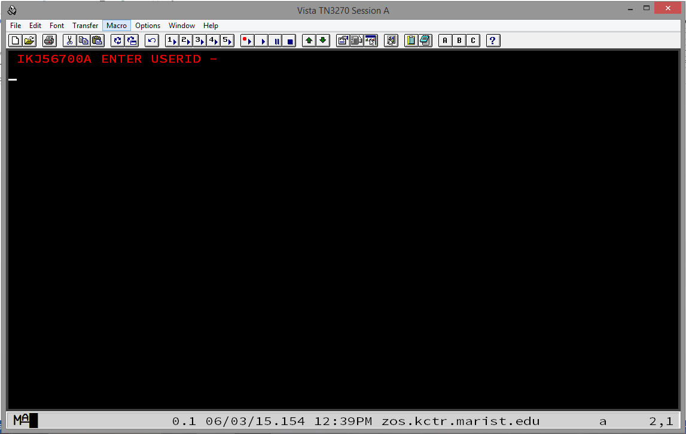

Enter your KC-ID as shown in the following:

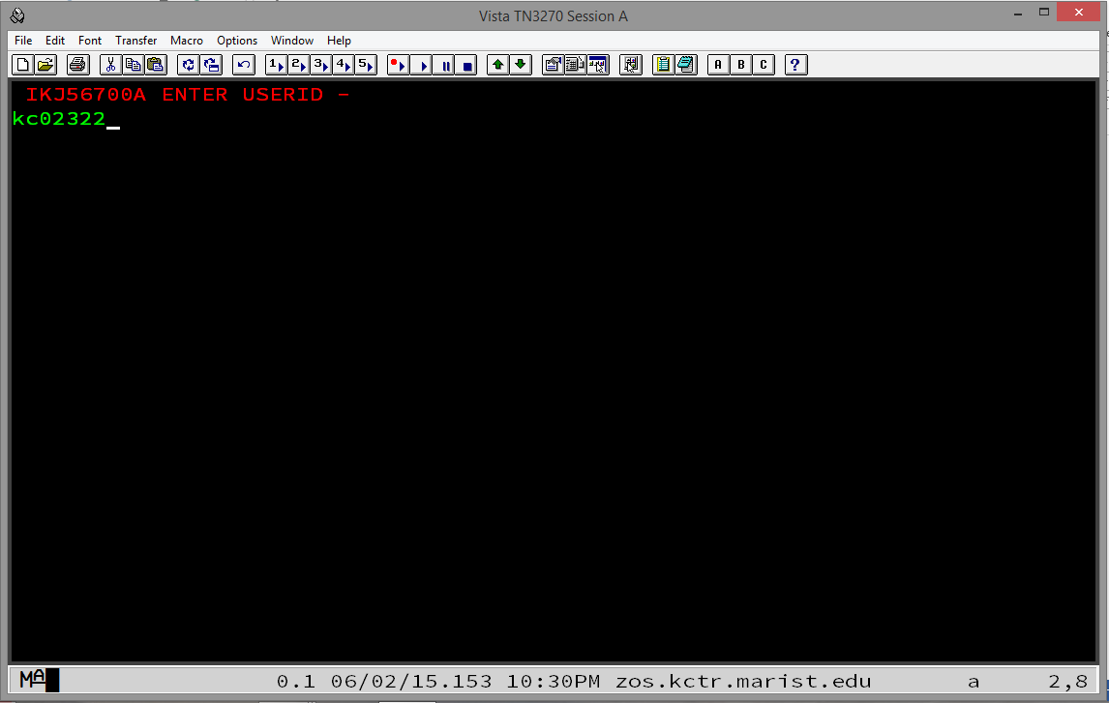

Press Enter and you will be presented the following:

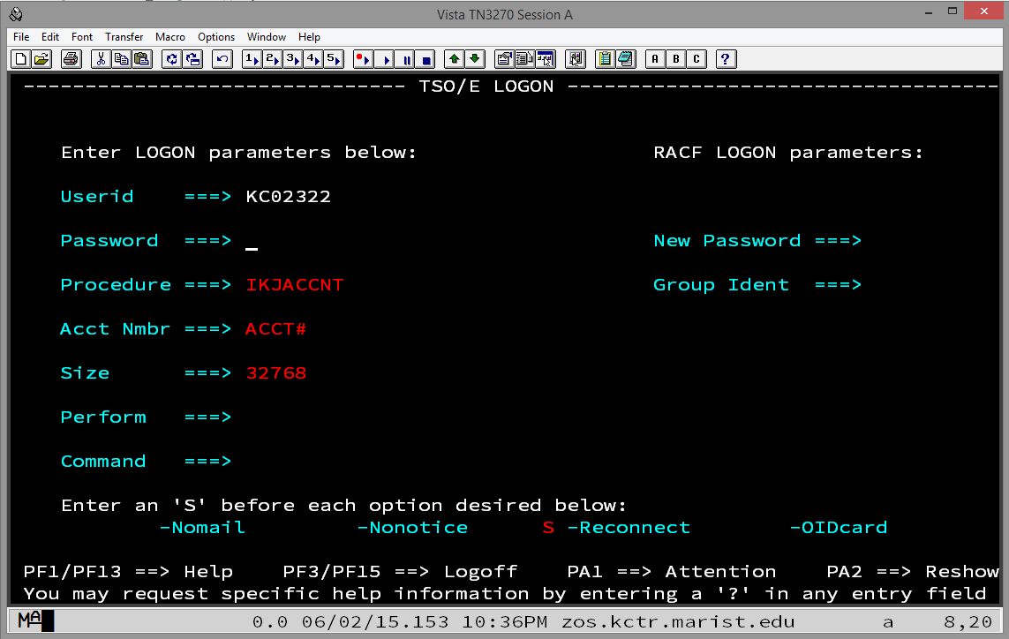

The first time you sign on your password is the same as your KC-ID. Enter it carefully and press Enter. You will be presented the following:

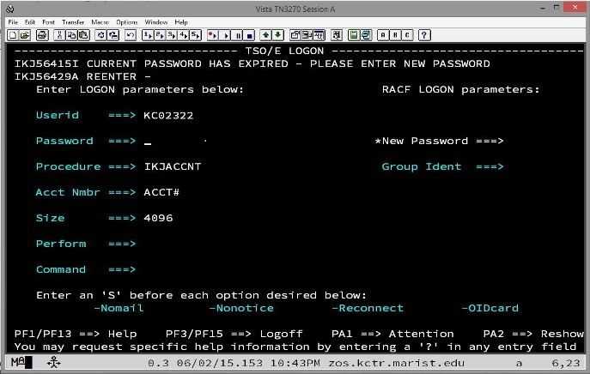

Enter a new password twice and you will be presented the following:

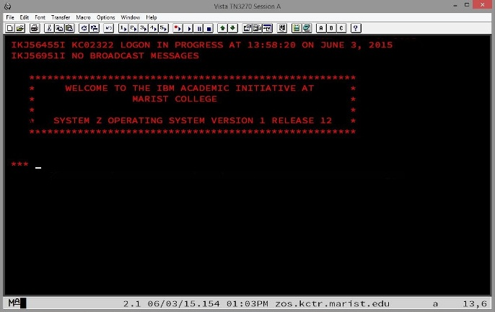

Note that your new password should be eight alphanumeric characters and should begin with a letter. It is NOT case sensitive. Again, you will have to enter it twice. Do so carefully. If you enter an eight-character password, the cursor will automatically tab to where you need to re-enter it to confirm it.

Press Enter again and you will be presented the following, the ISPF (Interactive System Productivity Facility) Primary Option Menu:

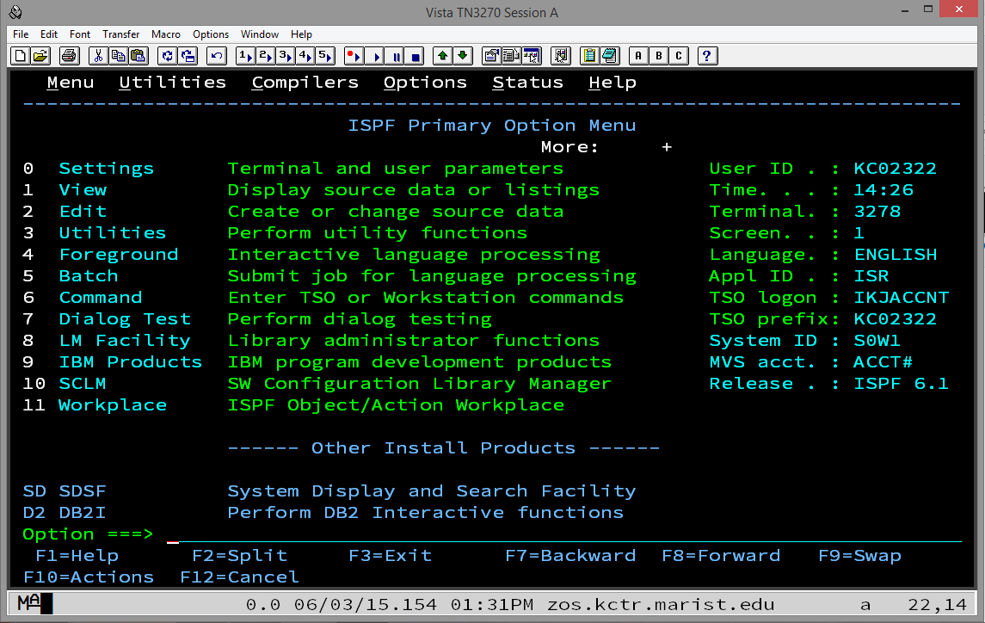

Although this looks complicated, you will only use Options 2 (Edit), 3 (Utilities), and SD (SDSF = System Display and Search Facility) for the remainder of the semester and, if you continue in mainframe studies, in CSCI 465/565 – Enterprise Application Environments.

A PDSE is sometimes called a "library." This is only because a PDSE, unlike a sequential data set, or "flat file," is separated into different members which are, in themselves, sequential files. Each of these members of a PDSE is somewhat like a book on a bookshelf in a library, hence the alias "library." So, a PDSE is a collection of members. You will create a new member for each assignment or other programming exercise this semester. The first one you will create will be named ASSIGN1 but first we need a PDSE to which we will add the member ASSIGN1.

To allocate a PDSE, enter 3 for Utilities and press Enter. You will be presented the following, the Utility Selection Panel:

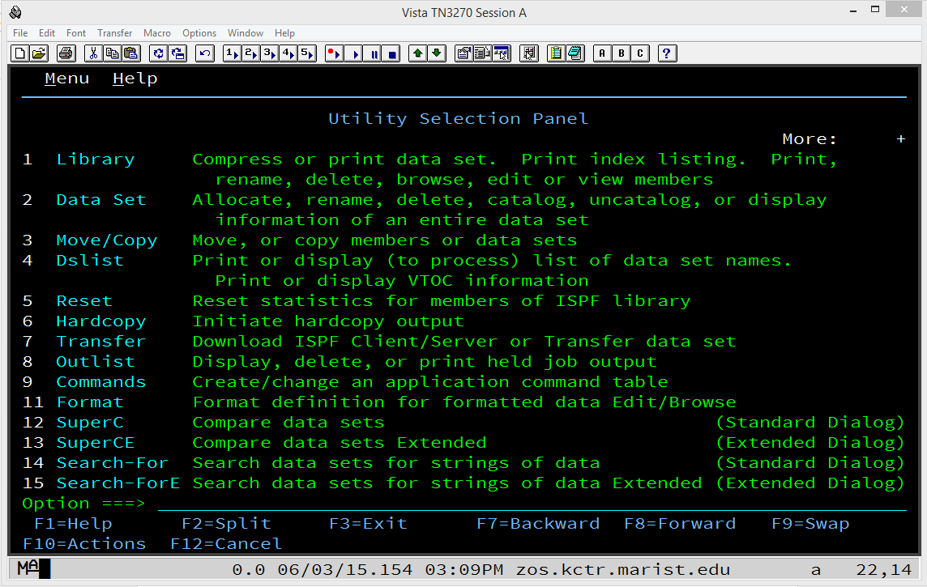

On this screen, enter 2 (Data Set) and press Enter. The first time you enter, you will be presented the following, the Data Set Utility panel:

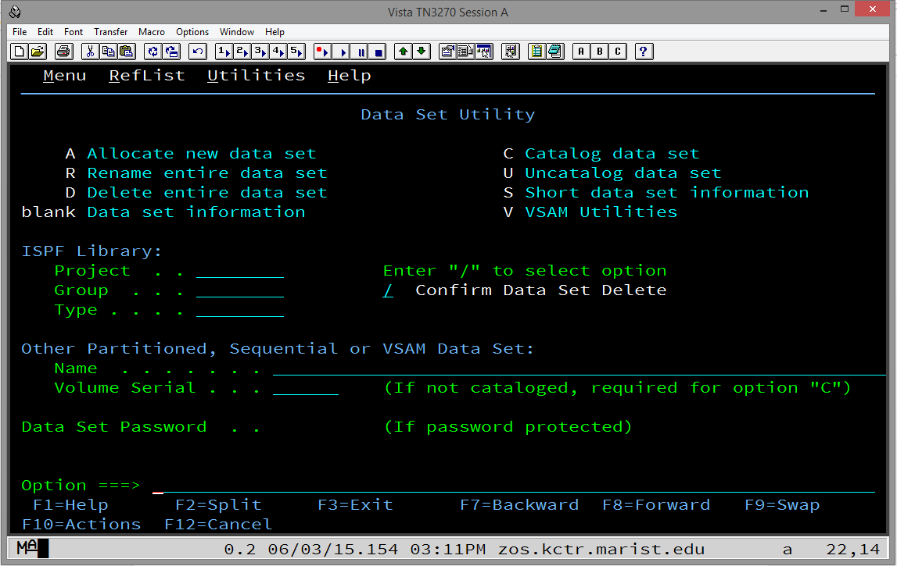

Move the cursor by tabbing or with your mouse to the line to the right of Project under ISPF Library: Type your KC-ID. Tab again to the line to the right of Group and type csci360. Tab again to the line to the right of Type and type the word assigns. Tab four times or move the cursor with your mouse to the Option ===> line at the bottom. Enter the letter a (for allocate) and press Enter.

Note that you can enter everything on the ISPF screens as lower case letters and the system will automatically change them to upper case. (This is not necessarily true for the Edit option that will be covered below.)

After pressing Enter, you will be presented the following, the Allocate New Data Set panel:

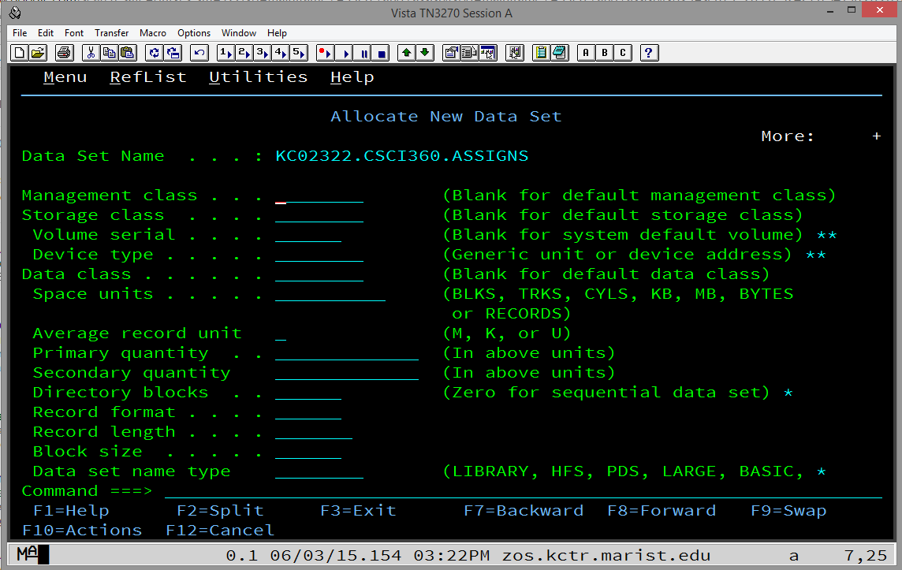

The first time you enter this panel, nothing will be pre-filled. But, the next time, it will be pre-filled with the parameters from the previous time you used this panel, i.e., the last time you successfully allocated a data set.

First, tab or use your mouse to move the cursor to the line to the right of Space units and enter CYLS for cylinders. Tab twice and enter 1 for Primary Quantity. Tab again and enter 1 for Secondary quantity. Tab again and enter 10 for Directory blocks. Tab again and enter FB for Record format. Tab again and enter 80 for Record length. Tab again and enter 880 for Block size. Tab again and enter LIBRARY for Data set name type.

Now press Enter.

After pressing Enter and, if the data set does not already exist (and it shouldn't!), you will be presented the Data Set Utility panel again with the message Data set allocated in white lettering in the upper right hand corner of the panel:

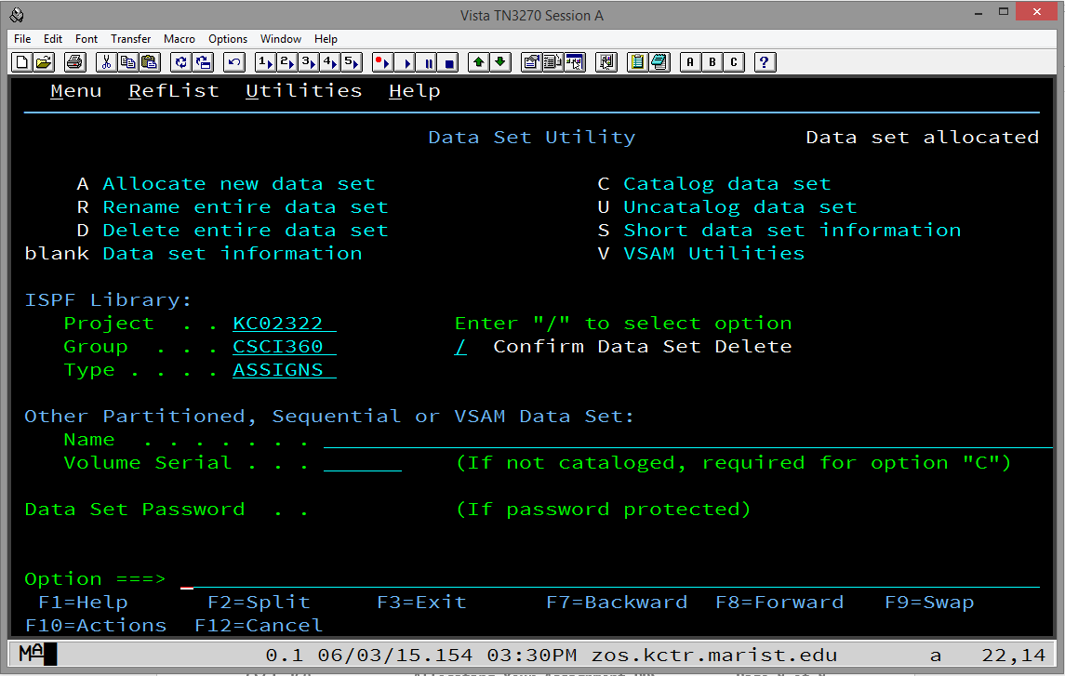

This indicates success! At this point, press F3 twice and you will once again be presented the following:



Now it is time to create and edit your first PDSE member. Enter 2 (Edit) at the Option ===> line and press Enter and you will be presented the following, the Edit Entry Panel:

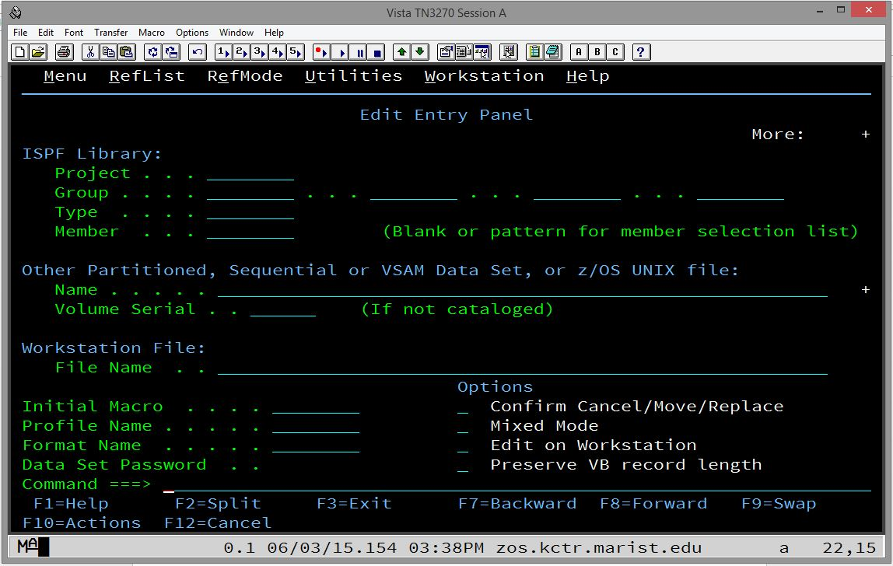

The first time you enter this panel, you will need to fill in some fields that will be pre-filled the next time you come back to it.

Tab a few times or move your cursor with your mouse to the line to the right of Project and enter your KC-ID. Tab once again and enter CSCI360 on the line just to the right of Group. Ignore the second, third, and fourth blanks and tab to the line just to the right of Type and enter ASSIGNS.

Finally, tab once more to the line just to the right of Member. It is here that you will enter the name of the member that you want to create and begin editing or you can enter the name of an existing member that you want to return to and continue editing.

At this point, please refer to the document named Editing in ISPF to learn how to edit a new or existing member of your PDSE.

To properly sign off TSO/ISPF, press F3 while in the ISPF Primary Option Menu. If you have made changes while signed on, you will be presented the following screen:

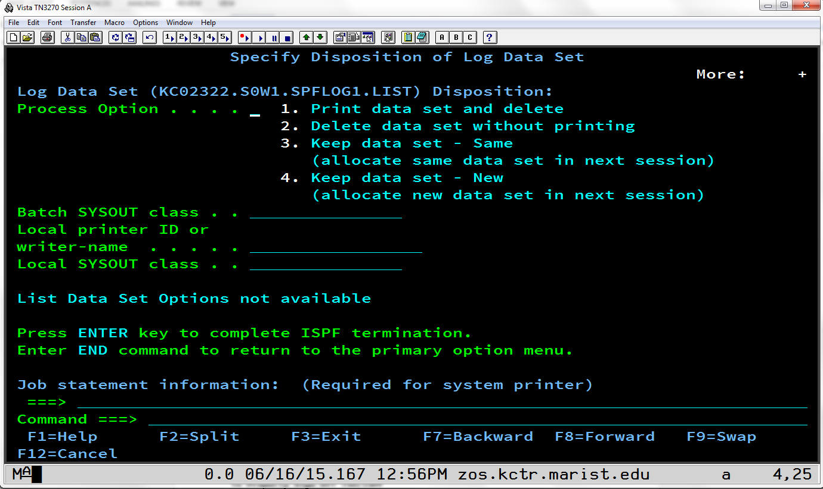

Type the number 2 and press Enter.

You will then be presented a screen with a red-lettered READY displayed as follows:

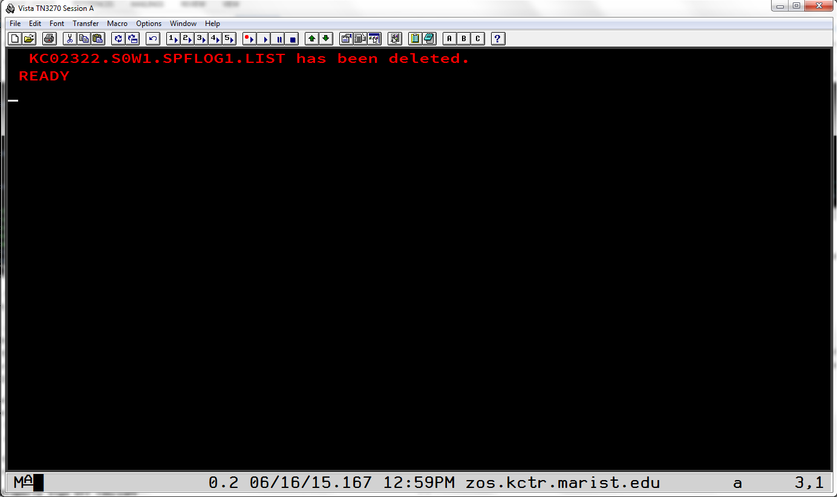

Type the word logoff or LOGOFF and press Enter and you will now be logged off Marist.